

Website - How to - Handbook.

# DRAFT

Vesion 1.0

2023/07/27

Contents

1. Front End
2. Back End
3. How to Create Products
4. How to Manage Orders

Front End:

Address: <http://sherrygordonsalon.great-site.net/>

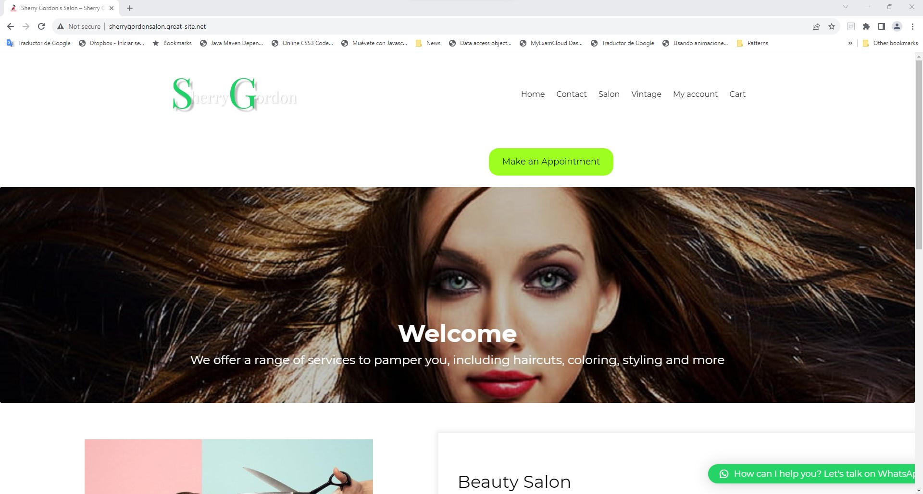

Back End:

Address: <http://sherrygordonsalon.great-site.net/wp-admin/>

The Back End is the private side of the website and is used for administrative purposes, for staff only.

You will use the back end to manage products and orders.

User: tester

Password: tester

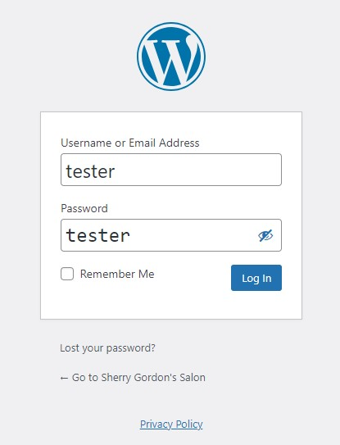

How to Create New Products ?

The Products Menu

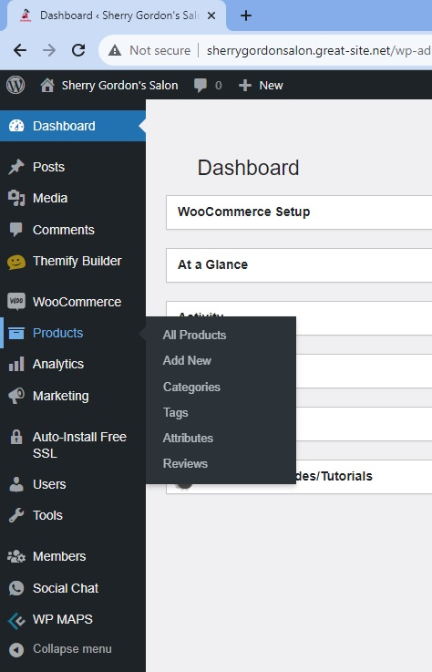

Click on the “Add New” option

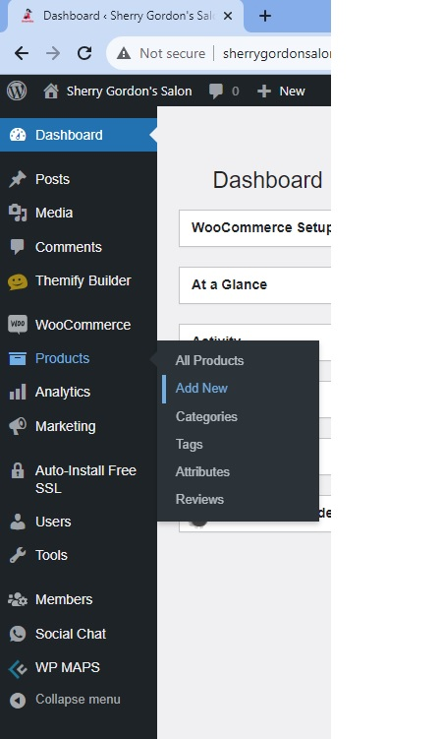

The “SherryGordonSalon” has two different types of products.

Those are:

- Services, like a Haircutt

and

- Articles from the Vintage Store

Services do not need a Shipment, but they are provided by appointment only.

Articles, instead, do not need an appointment but a Shipment Service is required.

How to add a “service product” from the Salon ?

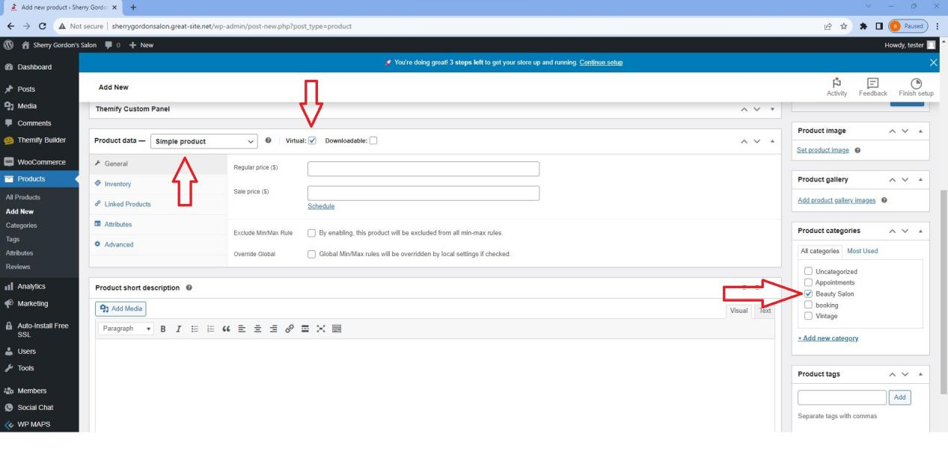

The screenshot shows the “Add New” product Form.

Let’s look at the “Product Data” section.

Virtual is a type of product that does not need a shipment. (like a haircut)

Beauty Salon Category tells the system that an appointment is mandatory.

Whether is a service or an article, it will be a “Simple Product”, always.

How to add an Article product from the Vintage Store ?

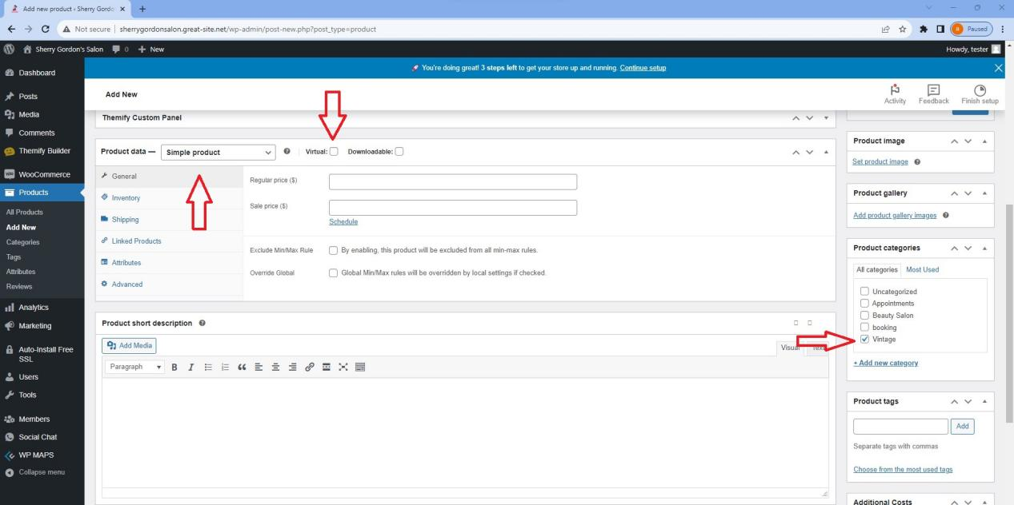

A Vintage Store item is NOT virtual, because it is a physical thing that has to be packed and shipped.

The Vintage category tells the system that an appointment is not necessary in this case.

As always, the main type is “Simple Product”

Other fields of the Form are common to both types of products.

Put prices.

Provide a Short Description.

Include some tags.

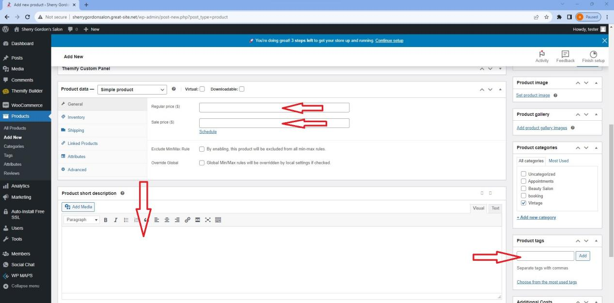

Write a Name and a Full Description.

Set an image for the product.

And finally, Publish it.

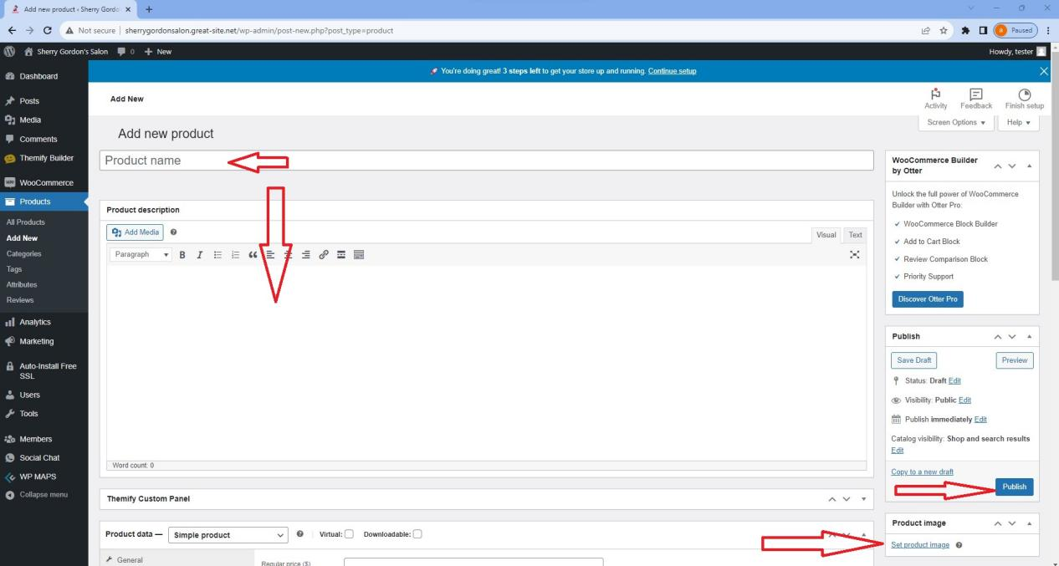

The new product is now online.

Explore the other options by yourself, like “Inventory”.

How to Manage Orders ?

When a customer buys something in the shop, an Order will be created.

Your can see the Orders List clicking on the “Woocommerce, Orders”, option.

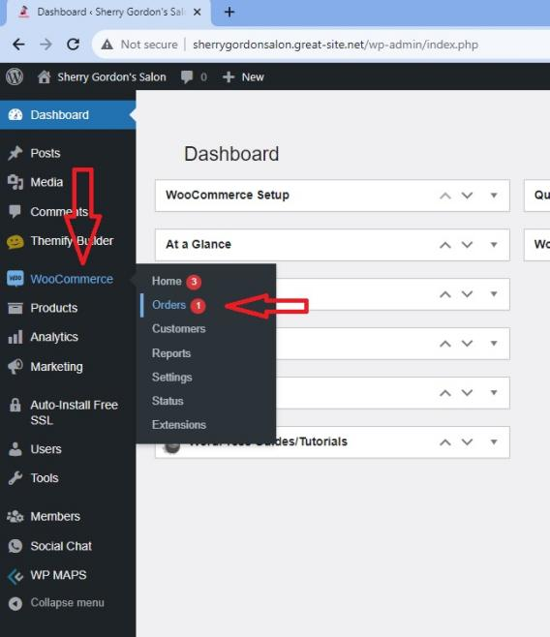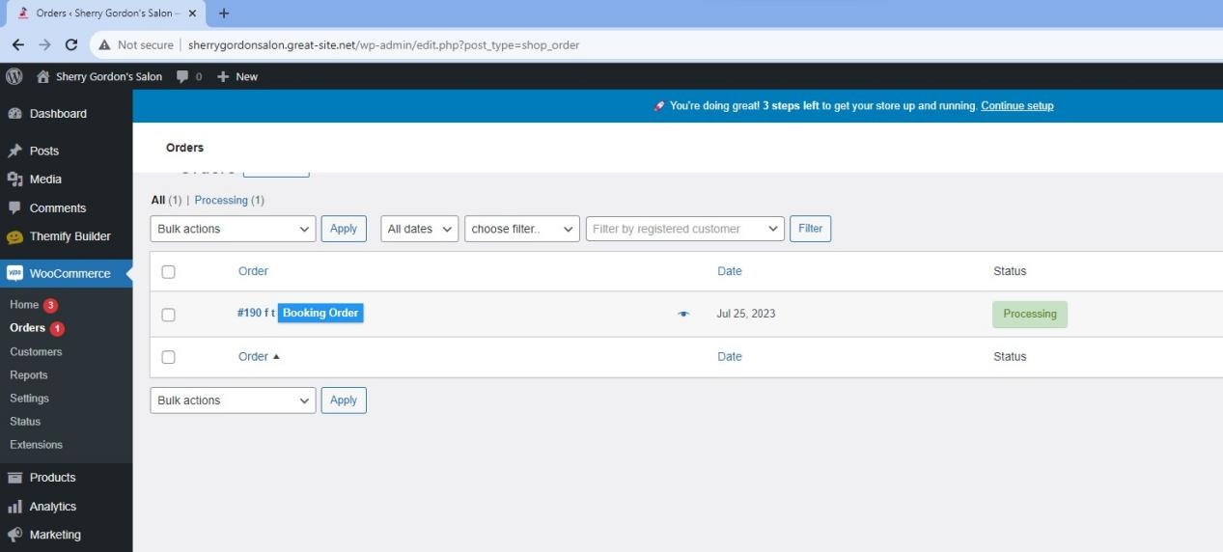

Click on an order to see the details.

